## Weather station locations

The site location is based in Brazil (Figure 1 and Table 1). The region is inside the subtropics with a distinct dry and wet season. The dry season lasts from April to September. To estimate the climate change at these sites the ensemble multi model mean of the last IPCC (AR5) assessment were considered. This consists of 39 climate model simulations. The ensemble mean is considered as the best estimate. The horizontal resolution of the climate models varies between about 150 km and 400 km. The ensemble mean does not therefore resolve any differences within the catchment area.

The chosen climate change scenario is RCP8.5 which is defined as a radiative imbalance of 8.5Wm-2 by 2100. This scenario is considered as a “business as usual” or worst case scenario. The chosen base line is 1980-2000 and the projection time frame is 2040-2060. The twenty year mean is suitable time period to define climatology for the site which also matches the available surface observations with the least data gaps. For projections with a time horizon of less than 50 years the choice of RCP scenario is much less important than for longer time scales (such as 2100) as the amount of projected warming to 2050s (considered here) is mostly dominated by model uncertainty and natural variability not emission scenario. The results presented here can be considered as conservative.

|  |  |  |  |
| --- | --- | --- | --- |
| **Station** | **Lat. (oC)** | **Lon. (oC)** | **Alt. (m)** |
| Diamantina | -18.23 | -43.64 | 1296 |
| Do Mato Dentro | -19.02 | -43.43 | 652 |
| 1843002 | -18.42 | -43.73 | 1107 |
| 1943003 | -19.25 | -43.01 | 452 |
| 1943025 | -19.22 | -43.37 | 571 |
| 1943035 | -19.22 | -43.59 | 1083 |

Table 1. Weather station and rain gauge information

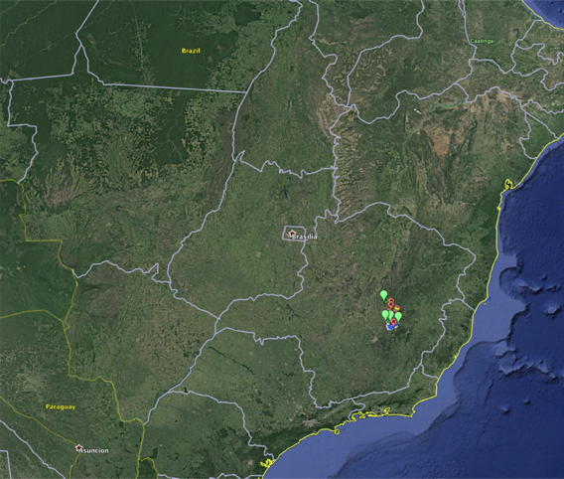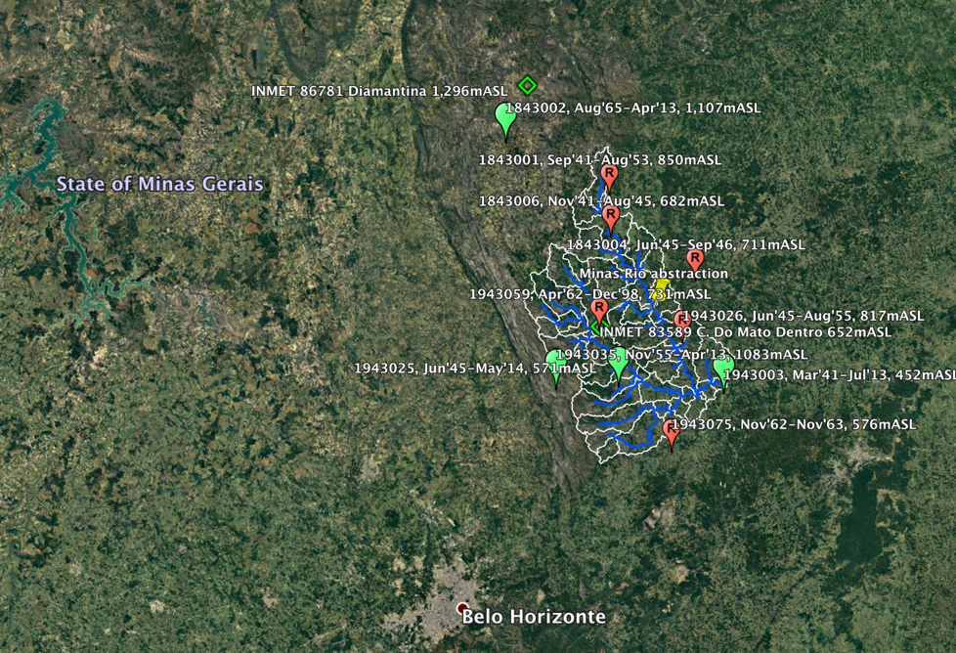

Figure 1. Map of rain gauges and weather stations in Minas Gerais, Brazil

Several tasks are presented:

1. A comparison of the observed mean and modelled climatology
2. Projections of monthly rainfall and mean temperature change.
3. Projections of consecutive dry spell and number of wet days.
4. Scaling of the observed data by the projections of the mean change and the number of consecutive dry days.
5. Identification of importance of El Niño on the monthly rainfall.

## Climatology and projections

### Rainfall

The station average and model base line rainfall is shown in Table 2. The model and the data both show a large seasonal cycle with a pronounced dry spell from April to September. In the annual mean the model rainfall is about 25% less than the observations suggest. This amount of difference is not untypical as climate models have lower skill in rainfall than, for example, temperature. There is no change in the projected for the annual mean precipitation. However, there is a large seasonal change in the projected rainfall.

|  |  |  |  |  |
| --- | --- | --- | --- | --- |
| **Month** | **Real**  **1980-2000 (mm)** | **CMIP5**  **1980-2000 (mm)** | **CMIP5**  **2040-2060 (mm)** | **CMIP5**  **change precipitation** |
| Jan | 9.51 | 6.37 | 6.79 | +6.7% |
| Feb | 4.69 | 5.37 | 6.00 | +11.7% |
| Mar | 5.73 | 4.36 | 4.42 | +1.4% |
| Apr | 2.79 | 1.68 | 1.69 | +0.2% |
| May | 1.00 | 0.59 | 0.55 | -7.6% |
| Jun | 0.31 | 0.43 | 0.40 | -6.0% |
| Jul | 0.17 | 0.40 | 0.38 | -3.7% |
| Aug | 0.44 | 0.48 | 0.43 | -11.2% |
| Sep | 1.36 | 1.00 | 0.80 | -19.6% |
| Oct | 3.23 | 2.48 | 2.06 | -17.1% |
| Nov | 7.68 | 4.83 | 4.49 | -6.9% |
| Dec | 9.83 | 6.71 | 6.67 | -0.7% |
| Annual | 3.90 | 2.89 | 2.89 | +0.0% |

Table 2. Rain gauge and CMIP5 model rainfall

The late wet season is somewhat wetter, with a peak increase in February of +11%. Most of the months show a decrease in rainfall with the largest decrease in the late dry season of about -20% in the transition month of September. There is therefore a clear shift in the seasonal rainfall cycle towards a wetter peak wet season and an extension of the dry season, while the annual rainfall total does not change. The planning implications are that if water is managed on annual basis little change is to expected, however for seasonal planning there could be a shift in the availability of water. The observed daily rainfall of the rain gauges at the four sites were scaled by a scaling factor of the projected monthly percentage changes.

### Temperature

The station average and model base line daily mean temperature is shown in Table 3. The model and the data both show a distinct seasonal cycle with a July minimum and December maximum. In the annual mean the model temperature is only 0.2oC less than the observations suggest. This amount of difference shows very high skill temperature. The projected annul mean temperature change is + 2.1 oC. The warming is projected to occur in all months with the larges change in November (+2.7 oC) and the least in February/March (+1.8 oC). The observed daily temperatures of the weather stations at two sites were scaled by adding the projected monthly change to them.

|  |  |  |  |  |
| --- | --- | --- | --- | --- |
| **Month** | **Real**  **1980-2000 (oC)** | **CMIP5**  **1980-2000 (oC)** | **CMIP5**  **2040-2060 (oC)** | **CMIP5 change temp (oC)** |
| Jan | 23.83 | 23.44 | 25.38 | **+1.9** |
| Feb | 23.99 | 23.53 | 25.34 | **+1.8** |
| Mar | 23.11 | 22.9 | 24.73 | **+1.8** |
| Apr | 21.71 | 21.42 | 23.4 | **+2.0** |
| May | 19.67 | 19.31 | 21.42 | **+2.1** |
| Jun | 18.06 | 17.57 | 19.71 | **+2.1** |
| Jul | 17.72 | 17.35 | 19.34 | **+2.0** |
| Aug | 18.88 | 18.74 | 20.78 | **+2.0** |
| Sep | 20.93 | 21.29 | 23.59 | **+2.3** |
| Oct | 22.8 | 23.16 | 25.77 | **+2.6** |
| Nov | 23.47 | 23.39 | 26.08 | **+2.7** |
| Dec | 24.04 | 23.33 | 25.54 | **+2.2** |
| Annual | 21.52 | 21.29 | 23.42 | **+2.1** |

Table 3. Weather station and CMIP5 model temperature

### Consecutive dry days and number of wet days

An important parameter for management could be the number of consecutive dry days. A dry day is defined as when the total rainfall on that day is less than 1 mm. The observations suggest that average consecutive number of dry days in a year for the baseline period (1980-2000) varies between 55 days and 78 days dependent on the site (Table 4). The model ensemble mean climatology is about 72 days which is in good agreement with the observations. The climate model project an increase in the number of consecutives dry days to about 82 days. This is consistent with a reduction of rainfall during the dry season as noted above.

|  |  |  |  |
| --- | --- | --- | --- |
| **Source** | **1980-2000 (no. days)** | **2040-2060 (no. days)** | **Tuning threshold**  **(no. days)** |
| CMIP5 ensemble mean | 71.8 | 81.9 | 1.00 |
| 1843002 | 77.9 | 89.1 | 2.22 |
| 1943003 | 67.5 | 76.3 | 1.60 |
| 1943025 | 54.7 | 62.5 | 2.22 |
| 1943035 | 66.0 | 75.5 | 2.14 |

Table 4. Number of consecutive dry days based on CMIP5 projections

The observed data is scaled by monthly rainfall projections and by the projected changes in consecutive dry days. The correct change in consecutive dry days is achieved by adjusting the threshold for the definition of dry day. For example, in Table 4 for station #1843002 the average number of consecutive dry days is increased from 78 to 89 or +14% as the climate model projections suggest. This is achieved by counting all days less than 2.22 mm (tuning threshold) as dry. The equivalent logic for number of wet days in a year is shown in Table 5, with the target from CMIP5 -7%.

|  |  |  |  |
| --- | --- | --- | --- |
| **Source** | **1980-2000 (mm)** | **2040-2060 (mm)** | **Tuning threshold (mm)** |
| CMIP5 ensemble mean | 118.3 | 109.6 | 1.00 |
| 1843002 | 86.9 | 80.5 | 1.29 |
| 1943003 | 81.3 | 75.3 | 1.55 |
| 1943025 | 102.0 | 94.6 | 1.29 |
| 1943035 | 97.8 | 90.63 | 1.28 |

Table 5. Number of wet days based on CMIP5 projections

This new threshold (the standard one would be 1 mm) also decreases the number of wet days by about 17%. This decrease of number of wet days is more than the climate models with a 1 mm threshold suggest (about -8% for this station).

We had to make a choice what is more relevant for understanding the hydrological impact the consecutive dry days or the number of wet days. Here we chose the number of consecutive dry days as a more important constraint. Dry days can occur throughout the year and are unlikely to affect the operations in the wet season. However the dry season may stress the system more. By applying the tuning threshold we are not changing the total rainfall. In the scaled time series we conserve the total rainfall by redistributing all the rainfall below the tuning threshold equally to all the wet days.

### El Niño

El Niño is a recurring equatorial eastern a Pacific warming pattern. It has an irregular period of 2-7 years. This phenomenon has an impact of the global mean temperature as well as regional rainfall patterns. The extent to which El Niño may change under climate change remains uncertain. In our assessment, we indirectly include any ensemble mean projected change in El Niño. It is however instructive to attempt to isolate the role of El Niño to improve our understanding The seasonal forecast of El Niño is also improving so that if there is strong control of El Niño on water availability then the water availability may itself be amenable to seasonal forecasting and thus seasonal decision making.



Figure 2. El Niño metrics against monthly precipitation. Significant values are triangles

El Niño can be defined as the sea surface temperature anomaly for different regions in the Pacific. Nino 1.2, 3, 3.4. and 4 refer to different areas in the equatorial Pacific. Figure 2 shows the correlation co-efficient of the different El Niño indices. There is not much difference between the indices. Only correlations of above about +/-0.25 are significant (p<0.05). Negative correlations are found for October and November, but are mostly positive in the other months. Interestingly for the transition month September, the month with the highest projected relative decline in rainfall, the correlation is positive. This suggests that a positive El Niño trend offsets the mean projected climate change of less rainfall in this month.

Diagnosing the wet and dry season separately shows the only significant correlation is found for the dry season. The correlation is positive so that more (less) El Niños would decrease (increase) the underlying climate change trend of less rainfall in the dry season.

An equivalent analysis for El Niño was done but by wet and dry season instead of by month (). The only significant results occurred in the dry season.

|  |  |  |
| --- | --- | --- |
| **Station** | **Metric** | **R** |
| 1843002 | nino3a | 0.26 |
| 1843002 | nino12a | 0.28 |
| 1943003 | nino4a | 0.31 |
| 1943025 | nino12a | 0.32 |
| 1943025 | nino4a | 0.34 |
| 1943003 | nino3a | 0.35 |
| 1943035 | nino4a | 0.37 |
| 1943025 | nino3a | 0.39 |
| 1943003 | nino3.4a | 0.39 |
| 1943035 | nino12a | 0.42 |
| 1943025 | nino3.4a | 0.42 |
| 1943035 | nino3.4a | 0.43 |
| 1943035 | nino3a | 0.46 |

Table 6. Significant correlations from regression between El Niño metrics and average monthly precipitation

IS THE REST JUST NOTES?

about 70 days and different for the individual sites.

* All weather station inside one grid square from CMIP5
* All scaling done for 2040-2060 from 1980-2000

Daily precipitation: monthly averages percentage differences between 1980-2000 and 2040-2060

* No change in overall annual daily average precipitation, but change in monthly distribution



Consecutive dry days: percentage change

* Tuned each rain gauge to get as close as possible to CMIP5 mean change of number of consecutive dry days (14.2%)
* Threshold tuning to do this, necessary when comparing data to model
* Redefinition of tuning threshold as 1mm, with rainfall added evenly to days over threshold to constrain the total rainfall for each month
* -7.3% was target for change in wet days, last column shows what we get with the consecutive dry day tuning threshold (i.e. sometimes quite off-target)

El Niño against seasonal precipitation

* Only significant values are in dry season (see next page for details)



|  |  |
| --- | --- |
| Wet | Jan,Feb,Mar,Oct,Nov,Dec |
| Dry | Apr,May,Jun,Jul,Aug,Sep |

* Only significant values are in dry season (see table below for significant results (p<0.05))